6

Bash Scripting

1. Create a script that asks for a filename and creates a backup of the file with current date. For example, if the filename is os_lab_5.docx the

backed up file should be like 23-10-

2017_os_lab_5.bak

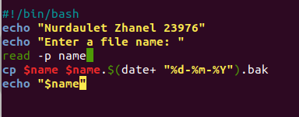

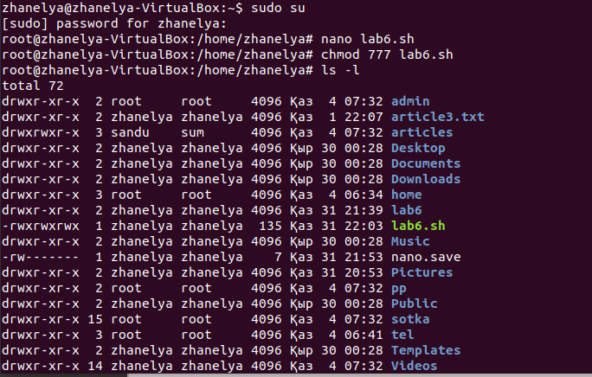

1. Create a script that asks for:
   * Username
   * Password expiry period
   * Password
   * Full name

And changes the full name and password for that user with new expiry period.

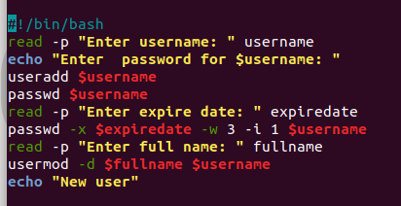

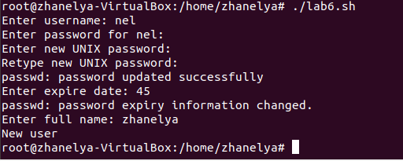

1. Create a script that asks for a directory name and creates a compressed backup of that directory.
   * Change the script so, that instead of directory name you will input the compressed filename and script should decompress that file.
   * 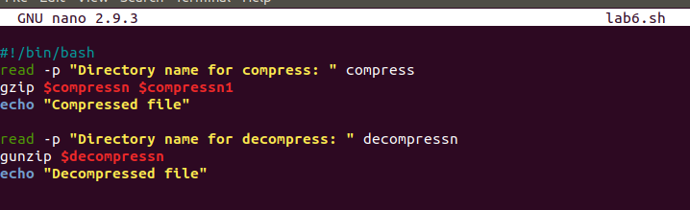

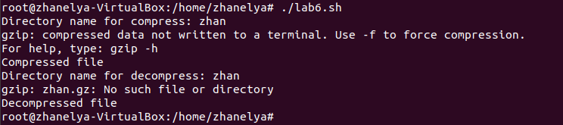

1. Create a script that asks for a filename and prints out the following information about file:
   * Filename
   * Type of file
   * Size of file
   * Created date of file
   * Permissions for this file
   * Owner of this file

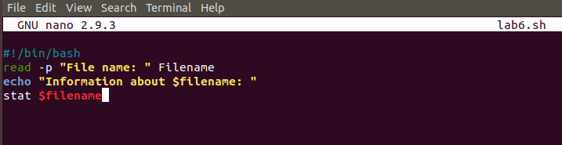

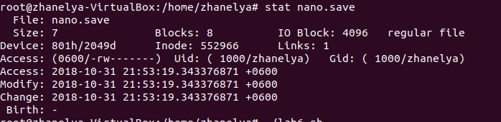

1. Create a script that asks for a name of file and the directory name and prints out all files with that filename in the given directory.
   * Change the script so, that instead of filename you will input the size of file and script prints out all files sizes of which is greater that inputted size.
   * 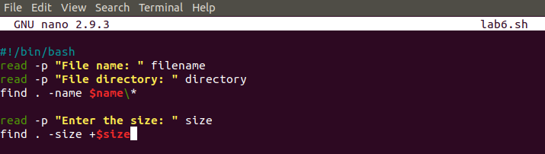
   * 
   * 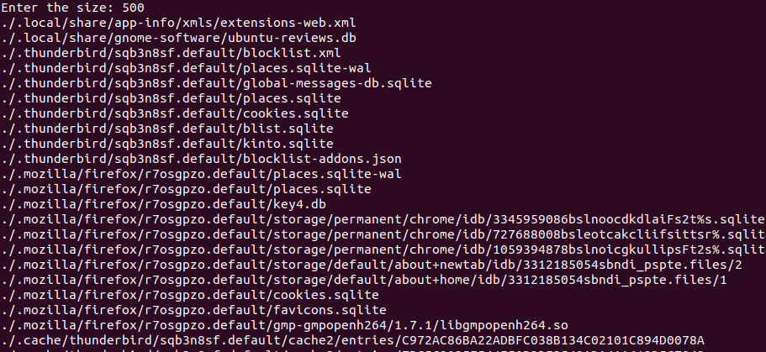

1. Create a script that asks for a filename and permission (in numbers) and changes the permission of that file to given.

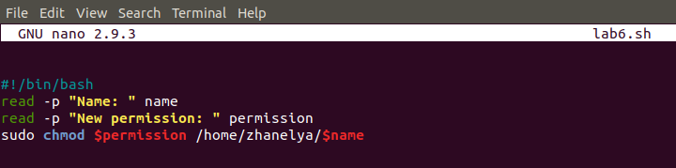

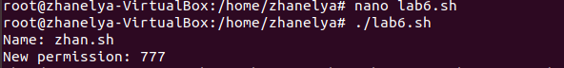

1. Create a script that asks for a website address or IP address and blocks this website or IP.

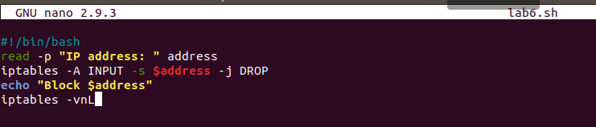

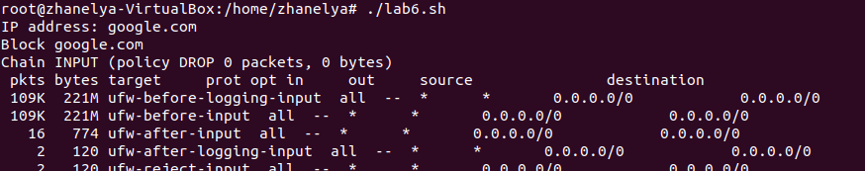

1. Create a script that asks for a directory name and size of file then deletes all files which size is greater than inputted size.

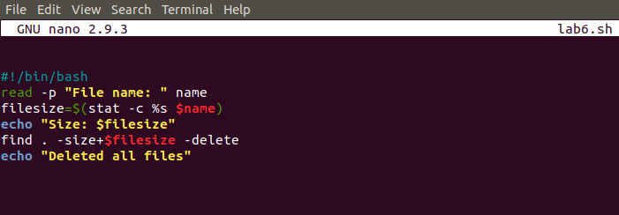

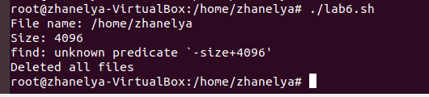

1. Create a script that asks for a source directory name and the destination directory name and copies all files from the first directory to the second.

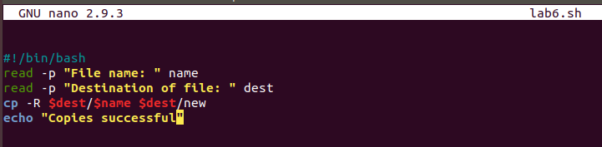 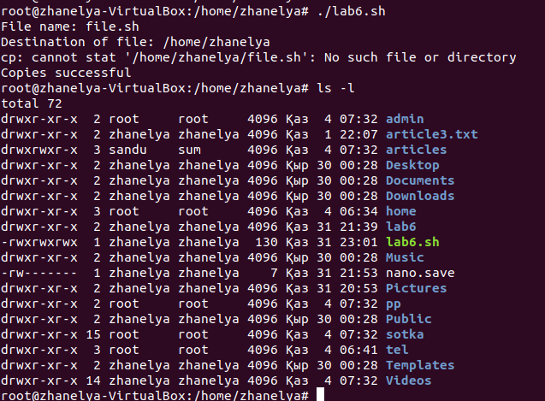

1. Create a script that asks for a directory name and removes all content of that directory

(including subdirectories and their contents)

